Team Charlie

Members: Elijah Wilkinson, Sean Christman, Gabriel Pedraza Torres, Dan Maher

Module: 9.1, Milestone # 1, Case Study: Outland Adventures

02/19/2023

**ERD**

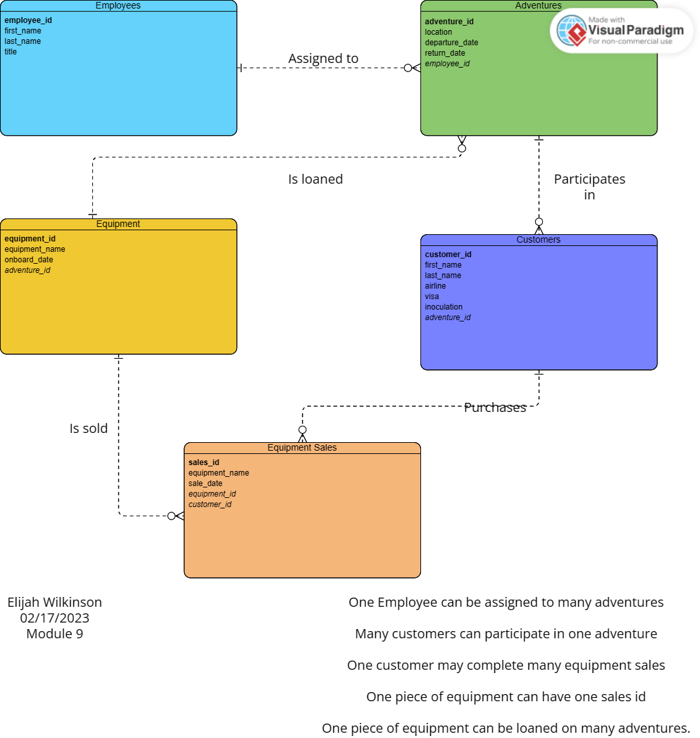

**Business Rules**

* An EMPLOYEE can be assigned to many ADVENTURES
* Many CUSTOMERS can participate in one ADVENTURES
* One CUSTOMER can purchase many pieces of EQUIPMENT(sales.)
* One piece of EQUIPMENT can have one SALES ID
* One piece of EQUIPMENT can be loaned on many ADVENTURES

**Assumptions**

I made assumptions for the data / records that populate in the tables / columns illustrated in the ERD. I made assumptions on the dates of travel, where each adventure last two weeks and the following adventure departs one week after the previous adventure returns.

I assumed that each guide “employee ID 3 and 4” take turns leading groups, so employee ID 3 is gone for two weeks, and then employee ID 4 leaves for two weeks one week after employee ID 3 returns, and this pattern continues.

The customer records were not explicitly stated, so names, airlines, visa / inoculation status as well as the adventure they enrolled in were assumed.

Onboard date in the Equipment table is generated to illustrate the equipment currently on hand and the age of the equipment so we can showcase equipment being over 5 years old to answer one of our case study questions.

Other data was assumed based on context of the company, its services, and what it might sell, how often customers may purchase equipment, as well as what adventures they’re going on.